Year 8 Computing Autumn Term Networking

ethernet  e / ther / net | Wired method:  For network connection.  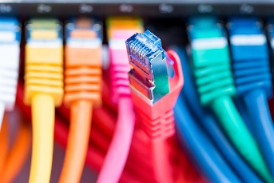

wireless/Wi-Fi | Wireless method:  To connect to networks.  

Bluetooth | Wireless, method:  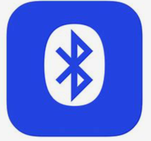  Of connecting devices over a short distance.

GPS | Satellite tracking system:  Used for navigation.  

1/2/3/4/5 G: | Wireless:  Mobile device communication technology.

network | Communication:  Several devices connected to be able to share information.  

networking hardware  net / work / ing hard / ware | Hardware needed to:    Enable computers / devices to connect to a network e.g. Hub, Router, Switch, NIC

router  rou / ter | Connects  Computers together with Ethernet or Wi-Fi Connections.

client | Any device  Connected to a network, it requests information from another device

server | Powerful computer  Receives and processes requests and sends the response.  

ISP  (Internet Service Provider)  in / ter / net ser/ vice pro / vi / der | Company that:  Provides you with a connection to the internet.

packets  pack / ets | Small chunk of data:  Sent over a network.

IP addresses  ad / dres / ses | Address for computers:  That packets are sent to and from e.g.  178.63.20.24

URL | Name  Of the website e.g.  www.google.com  

Python
variable  va / ri / a / ble | A named location:  In memory (RAM) used to store a value which can change.

syntax  syn / tax | Specifies the rules:  You must follow when creating code.  Structure of a language

bugs | Error in your code which:  Causes it not to run correctly.

selection / decision  se / lec / tion / de / ci / sion | One of:  Two paths of code will be run based on the result of a true or false test.

iteration  i / ter / a / tion | Section of code repeats:  A fixed number of times or until a condition is met.  Do this using a While loop

