
School Nursing Newsletter
July 2020
This newsletter aims to provide families and young people with some useful tips for keeping healthy. Childhood is an important time to develop healthy habits and learn crucial life skills. Establishing these habits early on will help to improve your child's quality of life in the future and enable them to reach their full potential.
School Nurse Support during COVID 19
During the COVID 19 pandemic school nurses are still available to support children, young people and their families to stay healthy, especially during these very stressful times.
If you have a concern regarding your child, please use the contact details at the bottom of this newsletter or visit our website which has lots of resources and information on COVID 19 and other health related topics.
Please watch our school nurse video here
Keeping healthy


Children should aim for 60 minutes of activity each day. We know that may feel difficult right now but visit https://www.nhs.uk/change4life for some great ideas for indoor and outside activities over the summer.
Physical activity can help improve concentration, co-ordination, general health, sleep and mood for all ages.

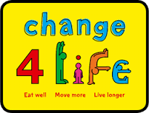
Remember the Water Safety Code This Summer

STOP AND THINK - Look for the dangers. Always read the signs.
STAY TOGETHER - Never swim alone. Always go with friends or family.
IN AN EMERGENCY - Shout for help and dial 999 or 112.
FLOAT - If you fall in, swim or float on your back. Throw something that floats to anyone who has fallen in the water https://www.rlss.org.uk/the-water-safety-code
Sleep
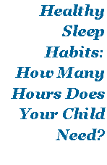
During the current restrictions on our lives daily routines are difficult to maintain and sleep patterns are probably being disrupted for all of us. Following a consistent bedtime routine is important.
The links below offer some guidance around this:
Healthy Sleep Tips
Sleep and Anxiety
You may also find that Sleep Meditation and Stories can help. There are some lovely ones to listen to here
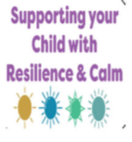
Supporting Your Child
Children react to what they see from adults around them. It is important that parents/caregivers deal with COVID19 calmly to help create a safe environment.
REASSURE THEY ARE SAFE: share the way that you deal with Stress.
KEEP A STRUCTURE: try to maintain a routine with mealtimes, bedtimes.
BE A GOOD ROLE MODEL: practice good coping skills that children will mimic.
The NSPCC site has some useful information here

Child and Adolescent Mental Health Services (CAMHS)


CAMHS offers a range of support for students and parents/carers, who have concerns around mental health.
For information on COVID-19 and your families wellbeing please click here
If you feel that your child requires a referral to CAMHS please click here.

You can also visit https://youngminds.org.uk/ which has a helpline.

Or visit https://www.familylives.org.uk/

helplinehelpline.


Bedwetting
Nocturnal enuresis, more commonly known as bedwetting, affects approximately half a million children and teenagers in the UK. Some people can find bedwetting an embarrassing subject to talk about and this can delay the child, young person or family from seeking help
Bedwetting can have a big impact on a child’s self-esteem and on their family life.

For more information, how you can help and when to ask for additional support please click here.
There is also the ERIC website which exists to give every child and teenager with a bowel or bladder condition support. You can visit the ERIC Site here.
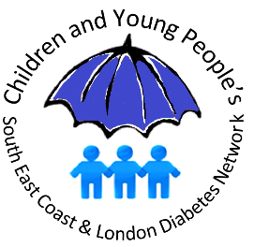
Diabetes
Undiagnosed Type 1 diabetes in children requires urgent medical attention.
If your child has ANY of the main symptoms of Type 1 diabetes please make an urgent GP appointment or contact the Out of Hours service.
The main symptoms are known as the 4 Ts
THIRST (often all the time)
TOILET (needing to urinate more often)
TIREDNESS
THINNER (losing weight)
If you notice your child is thirsty or using the toilet more frequently, is always feeling tired, or has lost weight recently, seek immediate medical advice.
NHS services are very well equipped to look after children safely if they are unwell. Please do not delay seeking medical advice because of Covid-19.
There is more information available here:
https://www.diabetes.org.uk/diabetes-the-basics/diabetes-symptoms

Sun safety
Don’t forget to stay safe in the sun. Experiencing severe sunburn, particularly in childhood, increases the risk of developing skin cancer in later life, so it's very important to protect yourself and your family from the sun. Follow the link to know how to stay safe here

How to contact your school nursing team.

Our School Nurse Support Line is available during the summer holidays.

Mon – Fri 9 - 4.30pm.
0118 9312111 and select ‘Option 4’


Visit our website here for more information on a variety of health issues.

