Piggott School Procedure
The Piggott School

Procedure: Safety Signs

Aim: To provide adequate signage where required

Reference documents:
HSE – Health and Safety (Safety Signs and Signals) Regulations 1996

Method:

- Signage
- Safety signage is used in the school where a hazard has been identified and cannot be completely removed to raise awareness of the hazard and precautions that need to be taken.
- Signage will be displayed in a clearly visible area as close to the hazard as possible.
- Signage will conform to the relevant British standard for signage and an information sign for understanding safety signage is displayed on the staff H&S notice board:

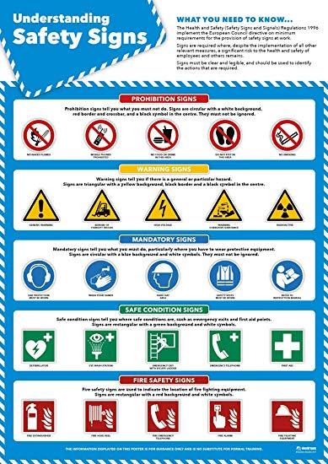

Issued by: David Corringham

Issue date: 23.09.2019

