Piggott School Procedure
The Piggott School

Procedure:

Manual Handling

Aim:

To reduce the risk of manual handling related injuries

Reference Documents:

- HSE publication: Manual Handling at Work
- Wokingham Schools Manual Handling – Inanimate Objects

Method:

Those at Risk
The school will identify those whose job roles involve manual handling tasks
Health and Safety courses will be provided for staff including safe manual handling

Visual risk assessment
Before attempting any manual handling task a quick visual risk assessment should be conducted taking into account all the sections below.

Can it be avoided?
Where possible manual handling should be avoided by eliminating unnecessary tasks or by arranging deliveries direct to end locations.

Reduce the risk.
Where manual handling cannot be avoided the risk should be reduced where possible
- Can large objects be split into smaller parts to reduce the load
- Can a trolley be used
- Can a lift be used
- Do the task require more than one person

Extra care should be taken when doing the following and avoiding and reducing the risk should be taken into account:
- Lifting objects above shoulder height
- Lifting objects from the ground
- Lifting heavy object
- Lifting large objects
- Lifting objects with an uneven load
- Carrying objects for an extended period

Consider your route
- How far do you have to travel
- Is the route on even surfaces
- Are there stairs, doors or other obstacles
- Can it be done at times of less foot traffic in that area

Lifting Safely
Care should be taken to lift objects safely, the following diagram offers some advice on good practice when lifting. If you are unsure how to lift an object safely do not attempt it and seek advice.
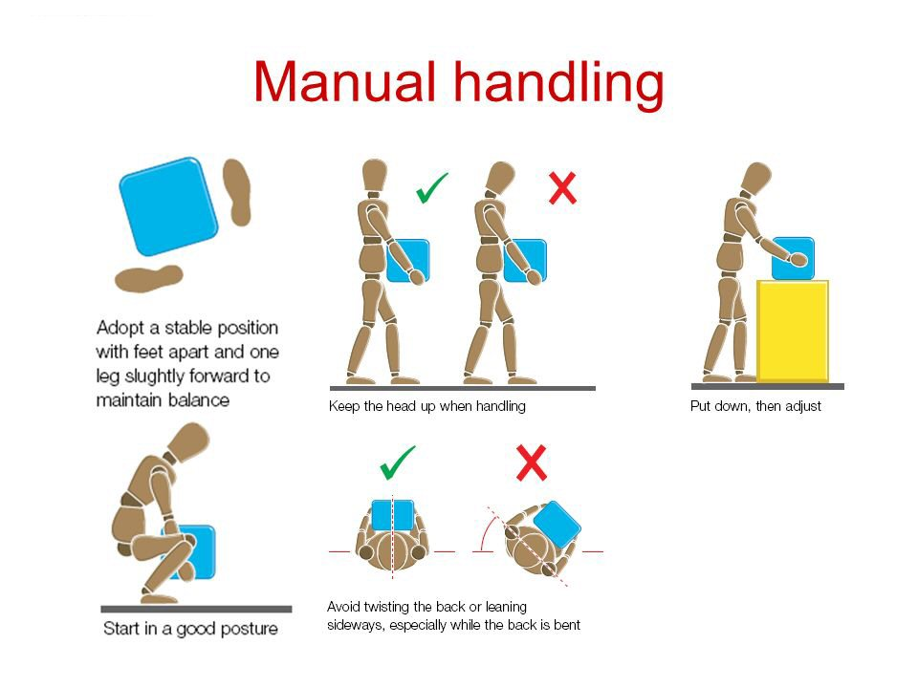

Issued by:

David Corringham

Issue date:

12.01.2021

